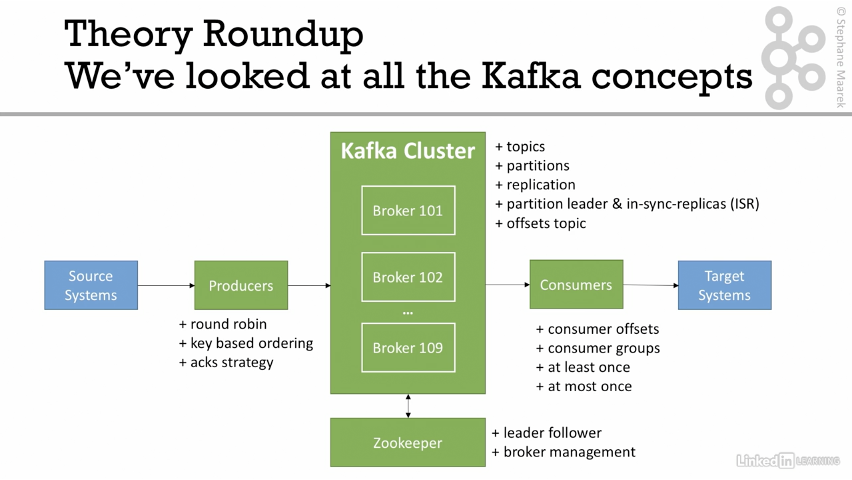

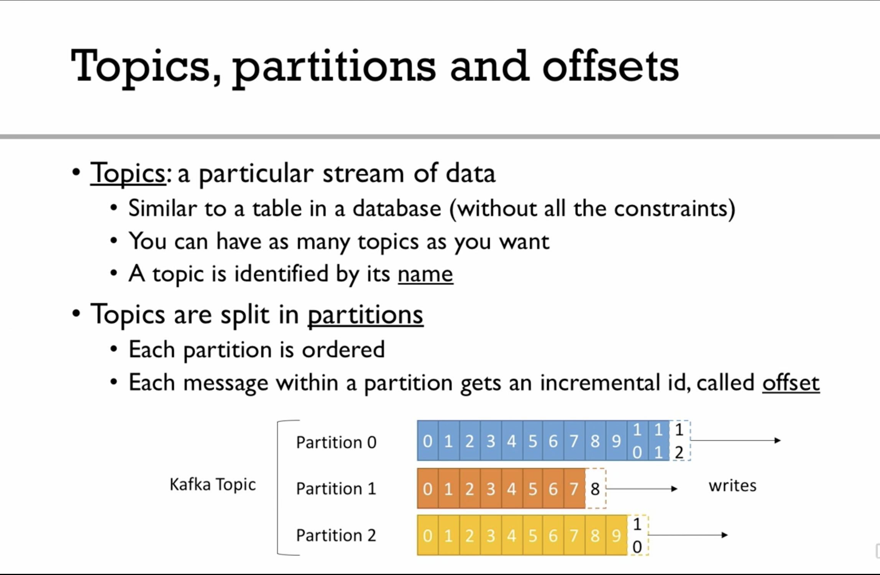

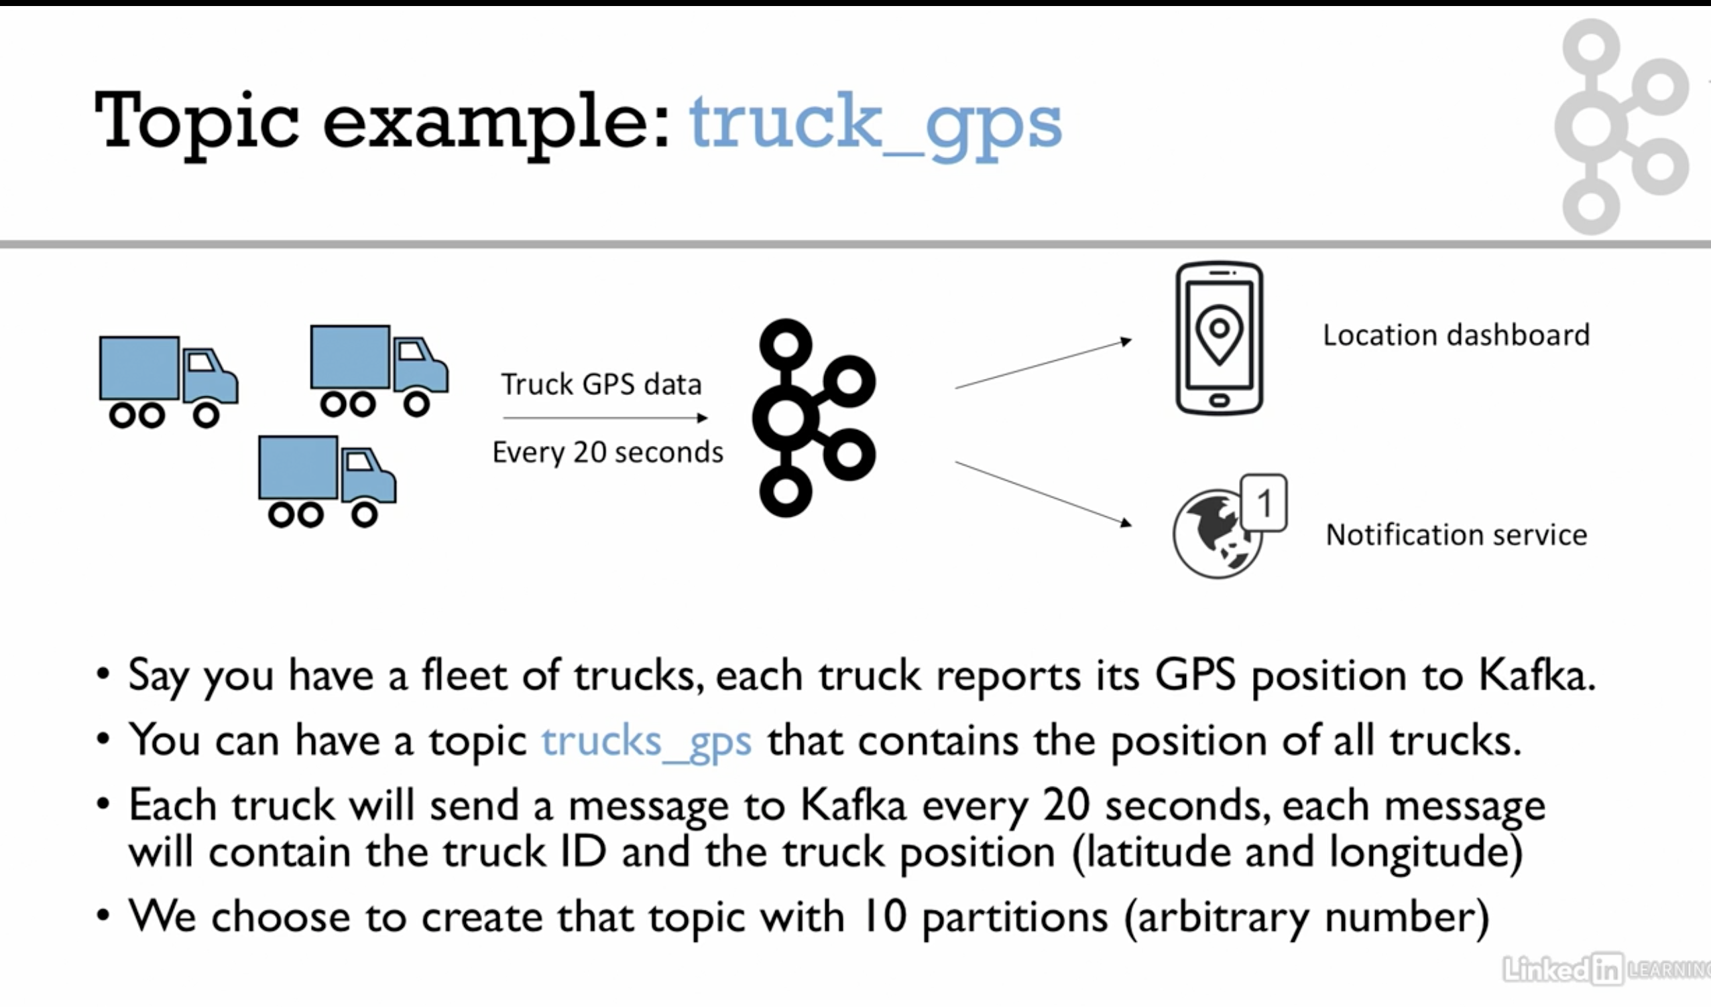

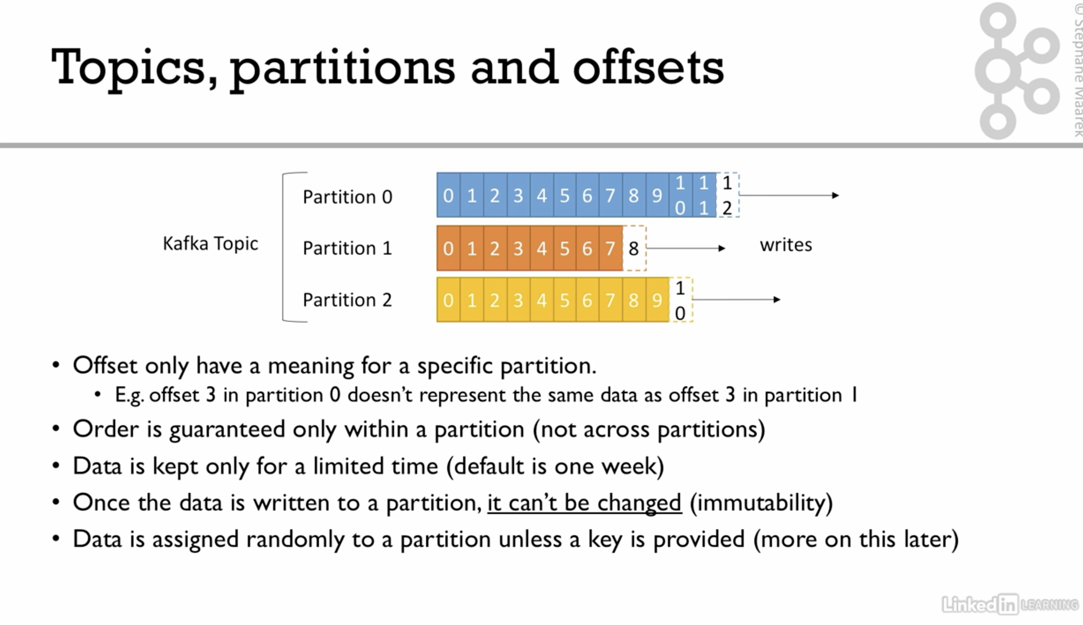

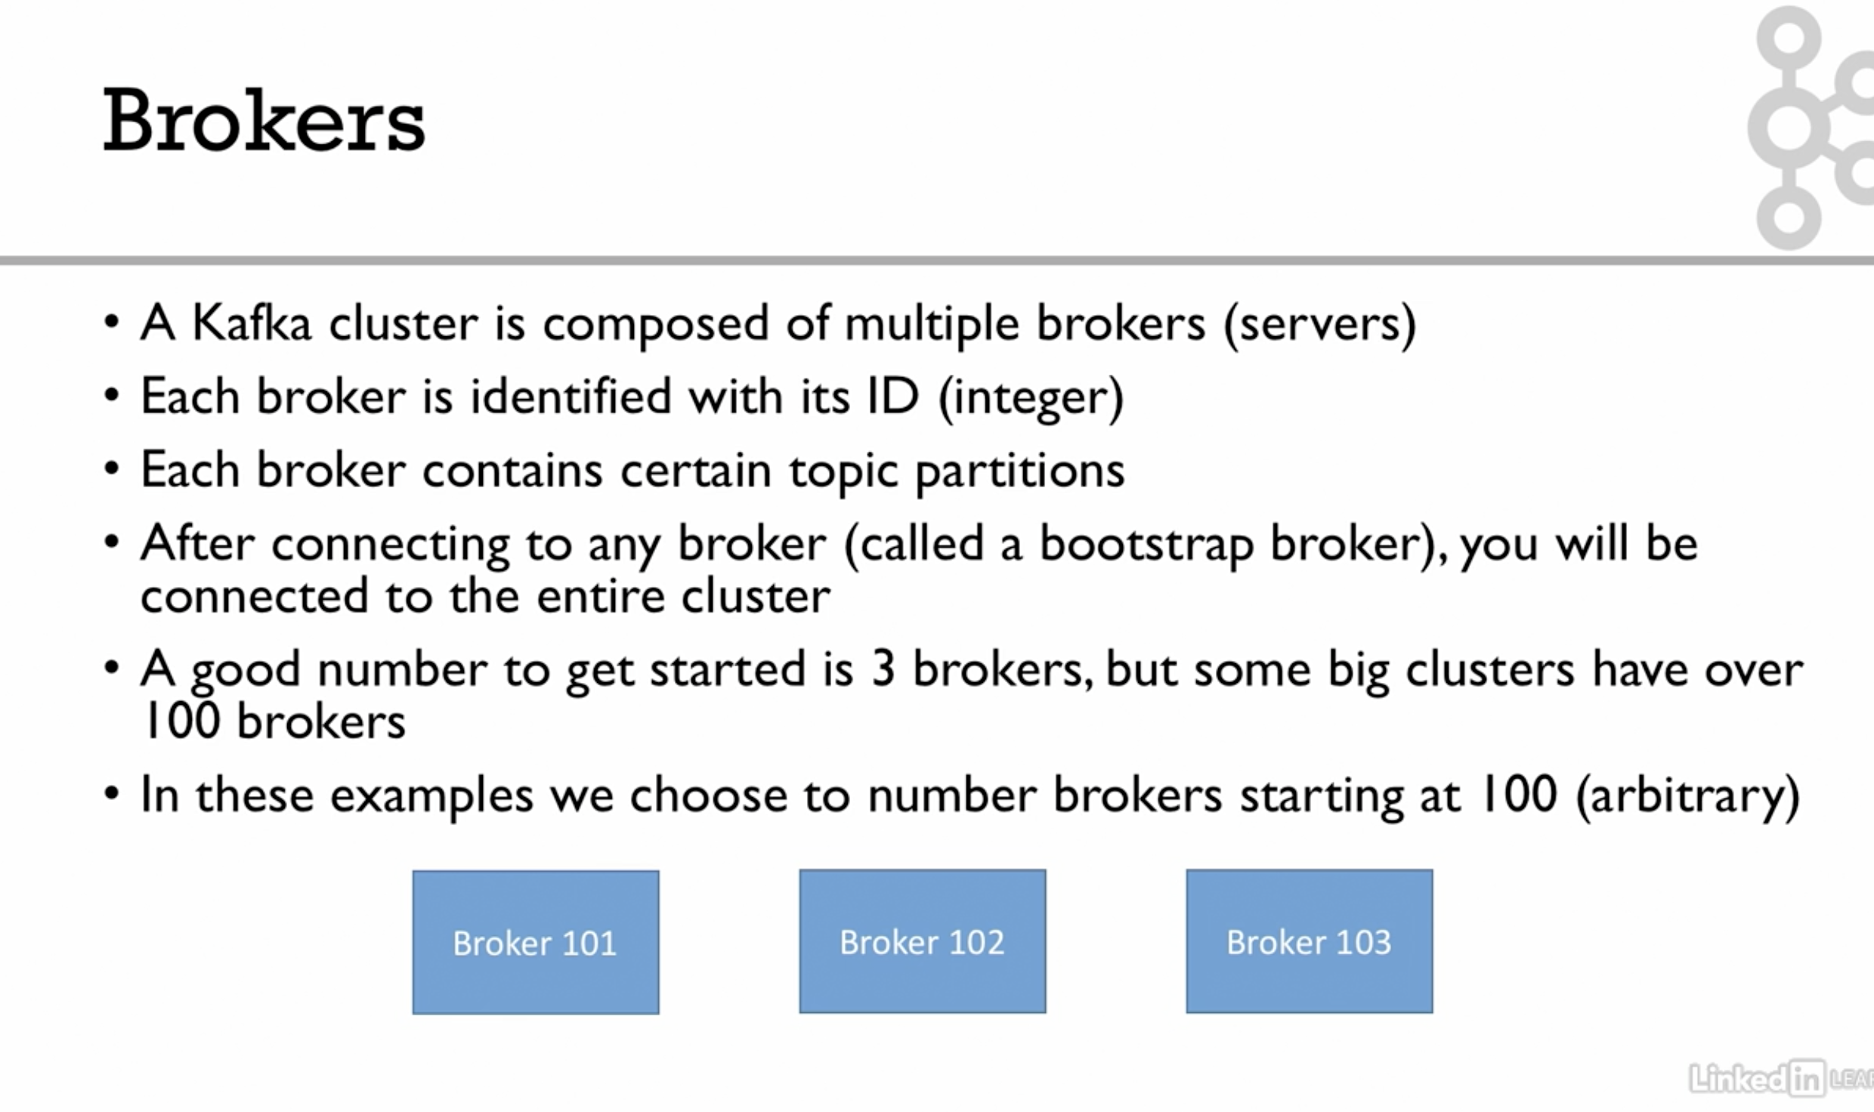

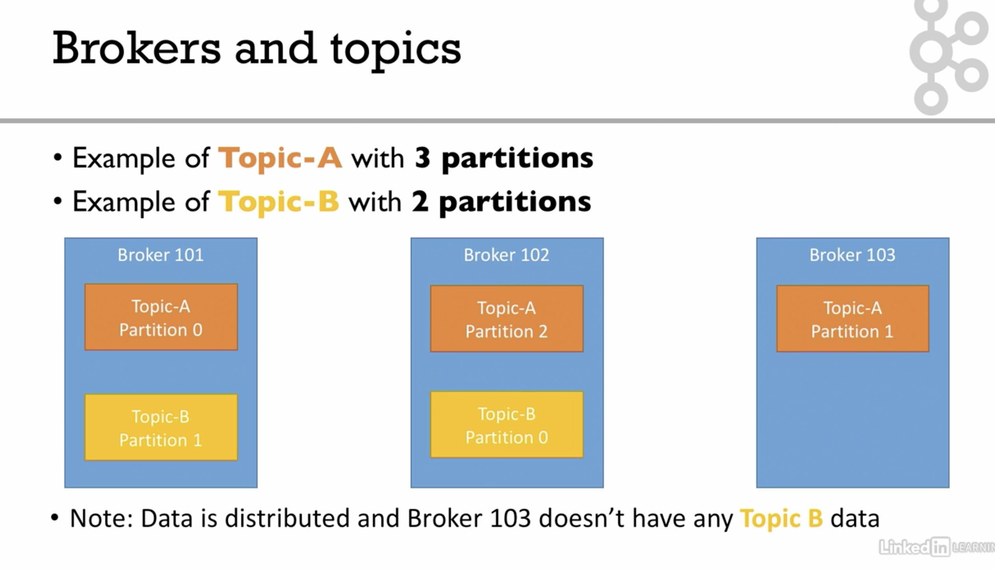

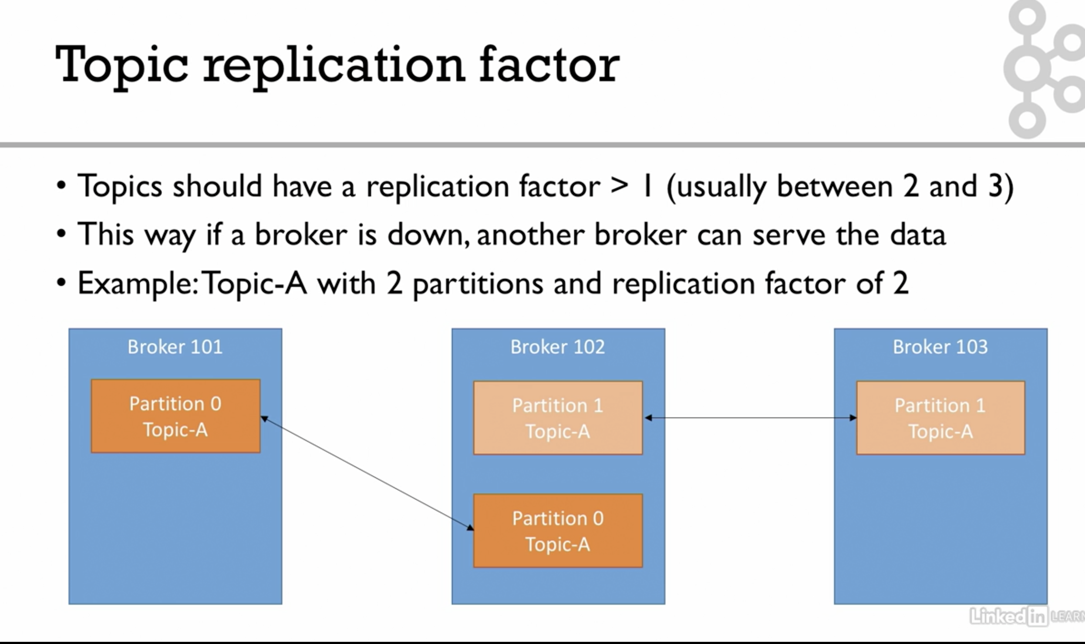

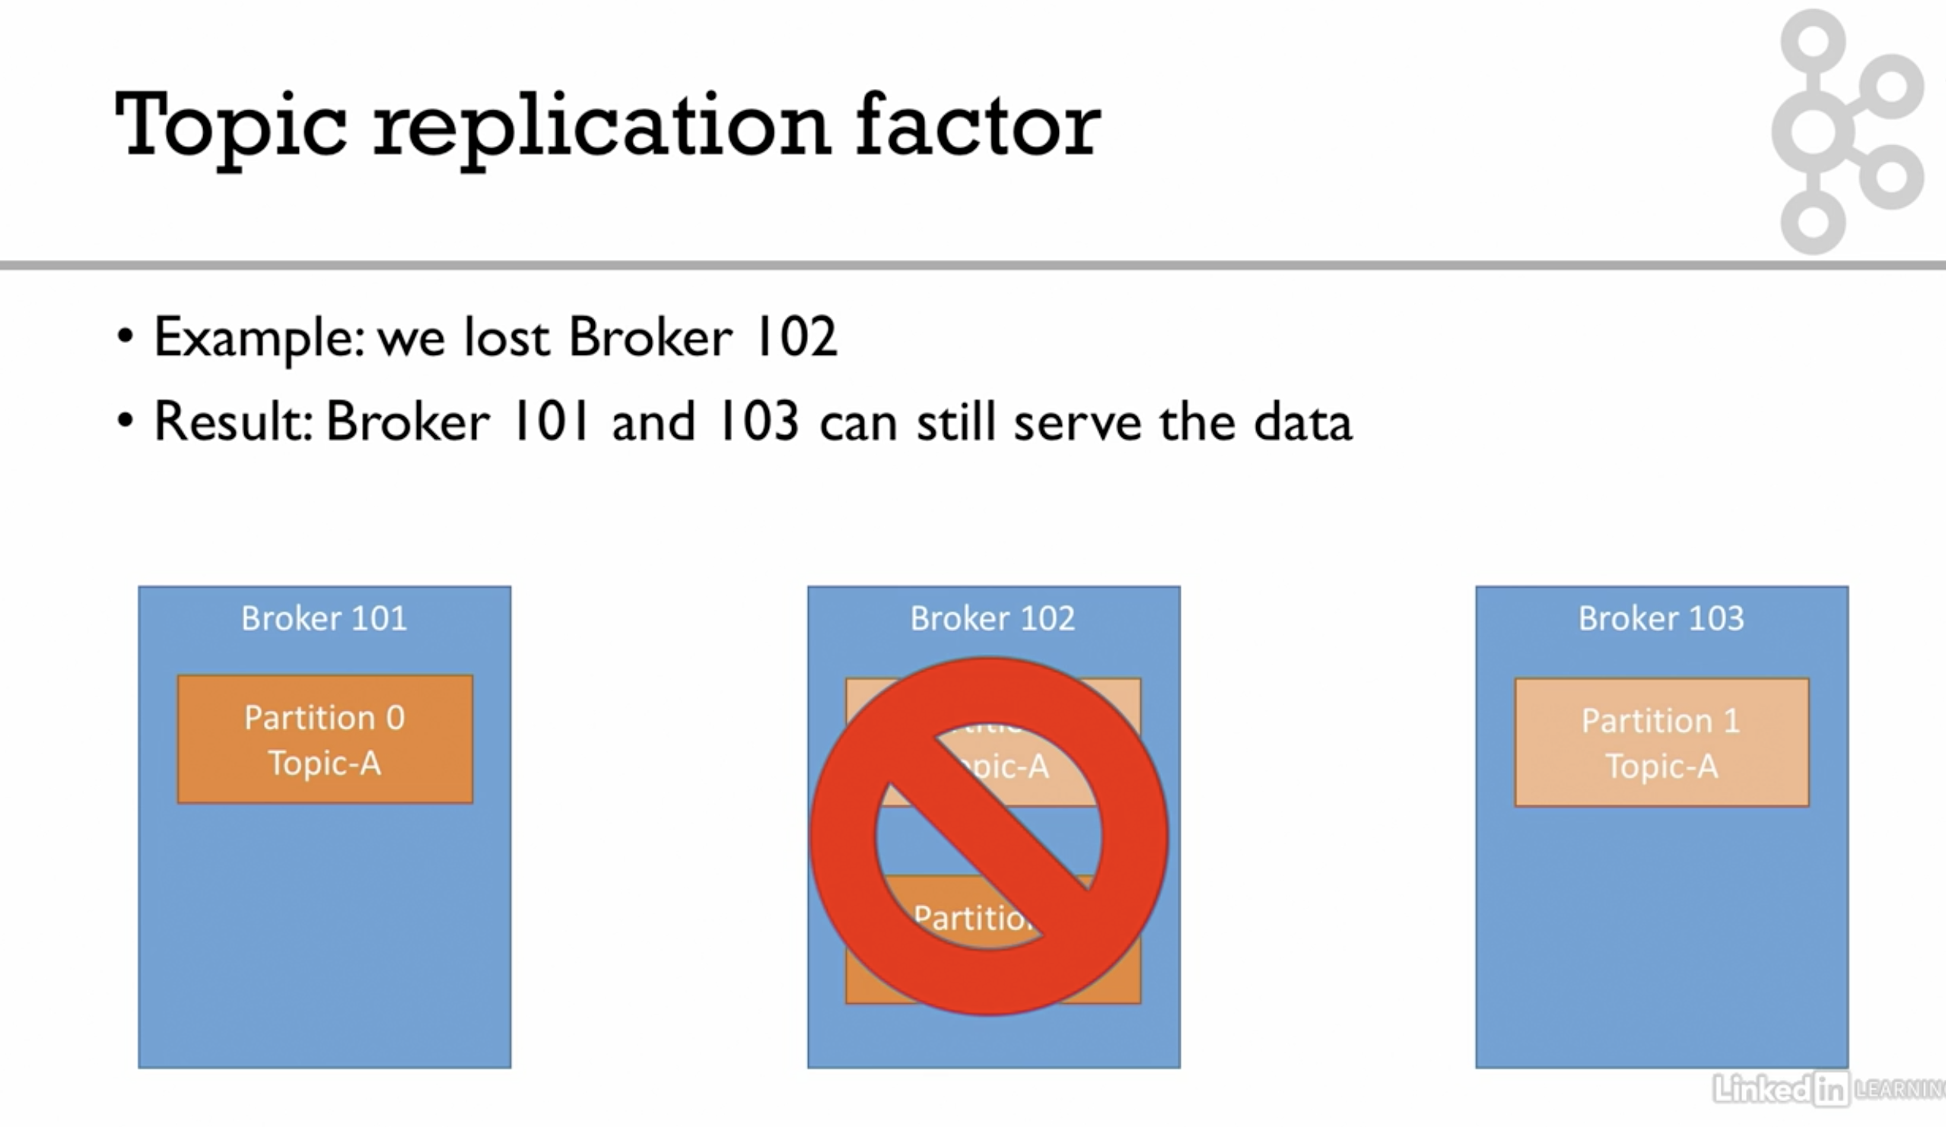

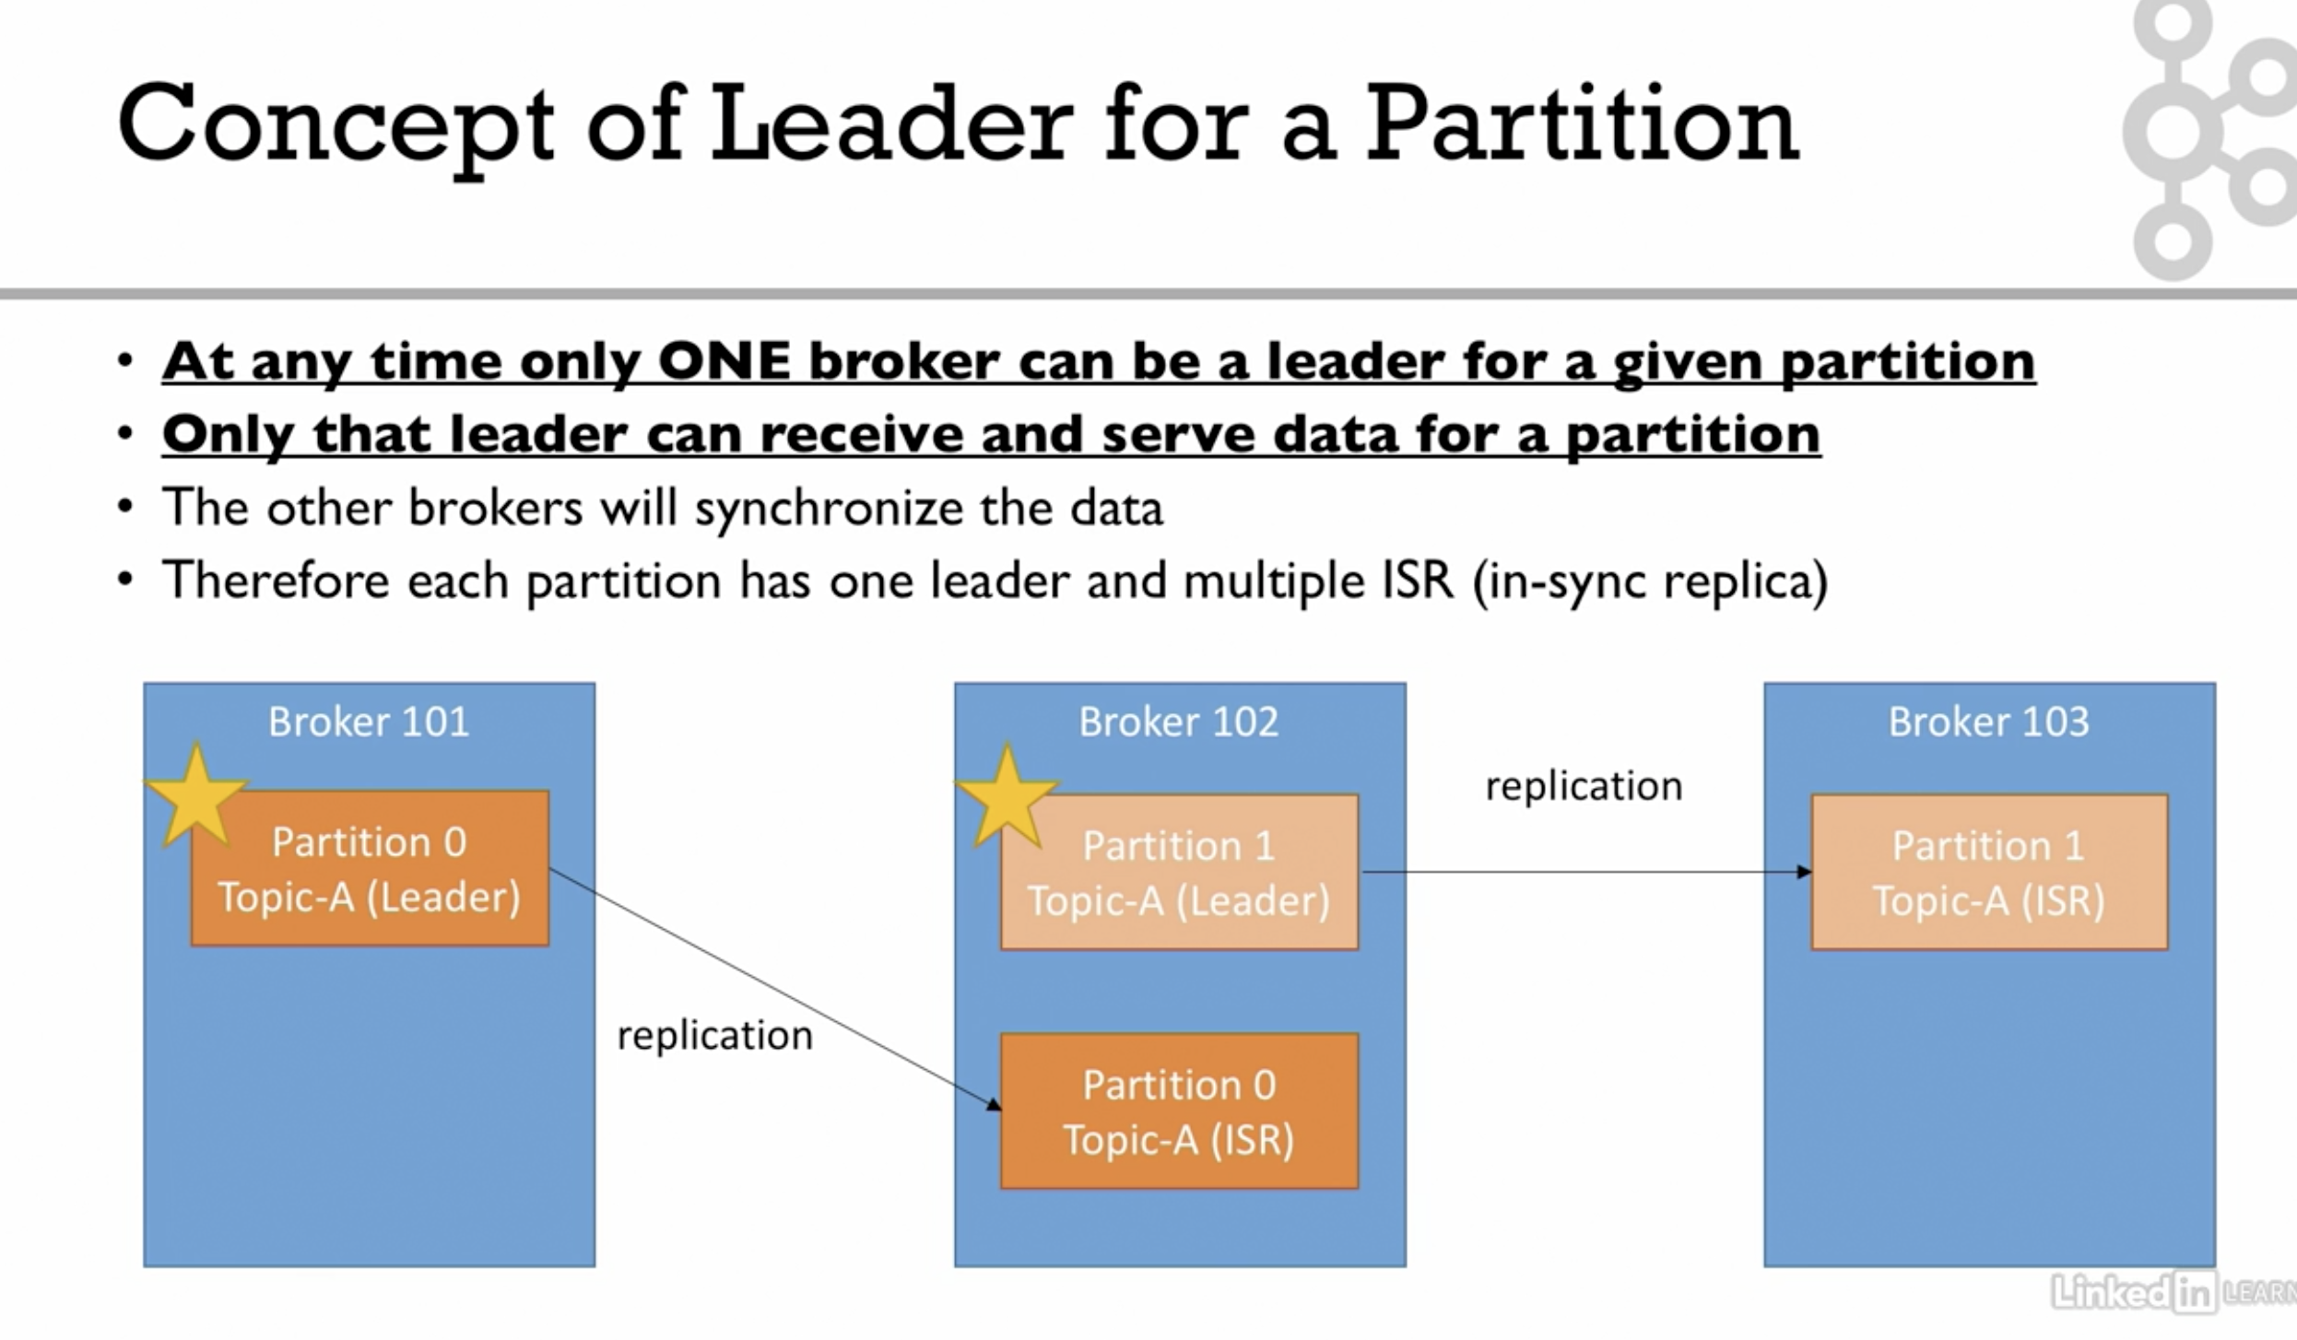

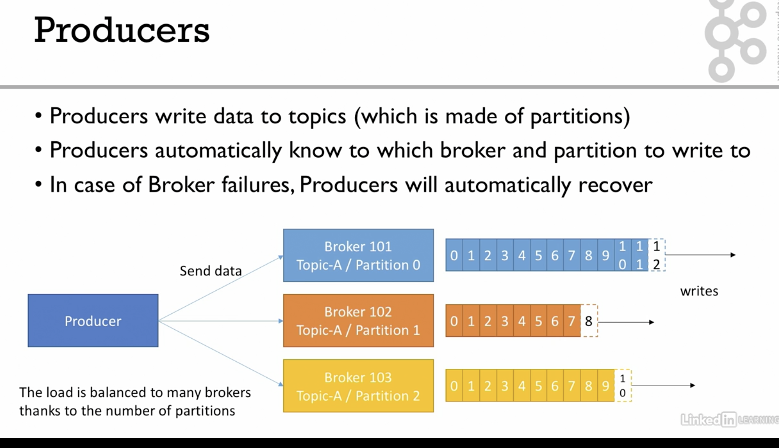

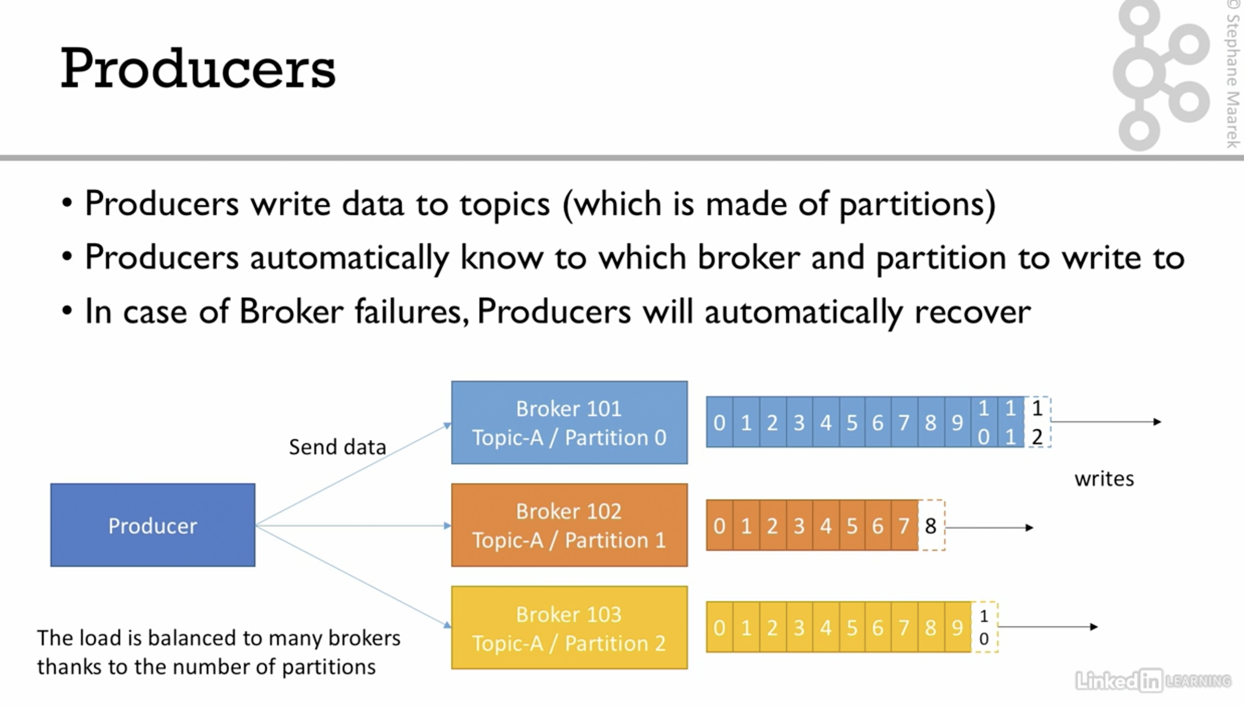

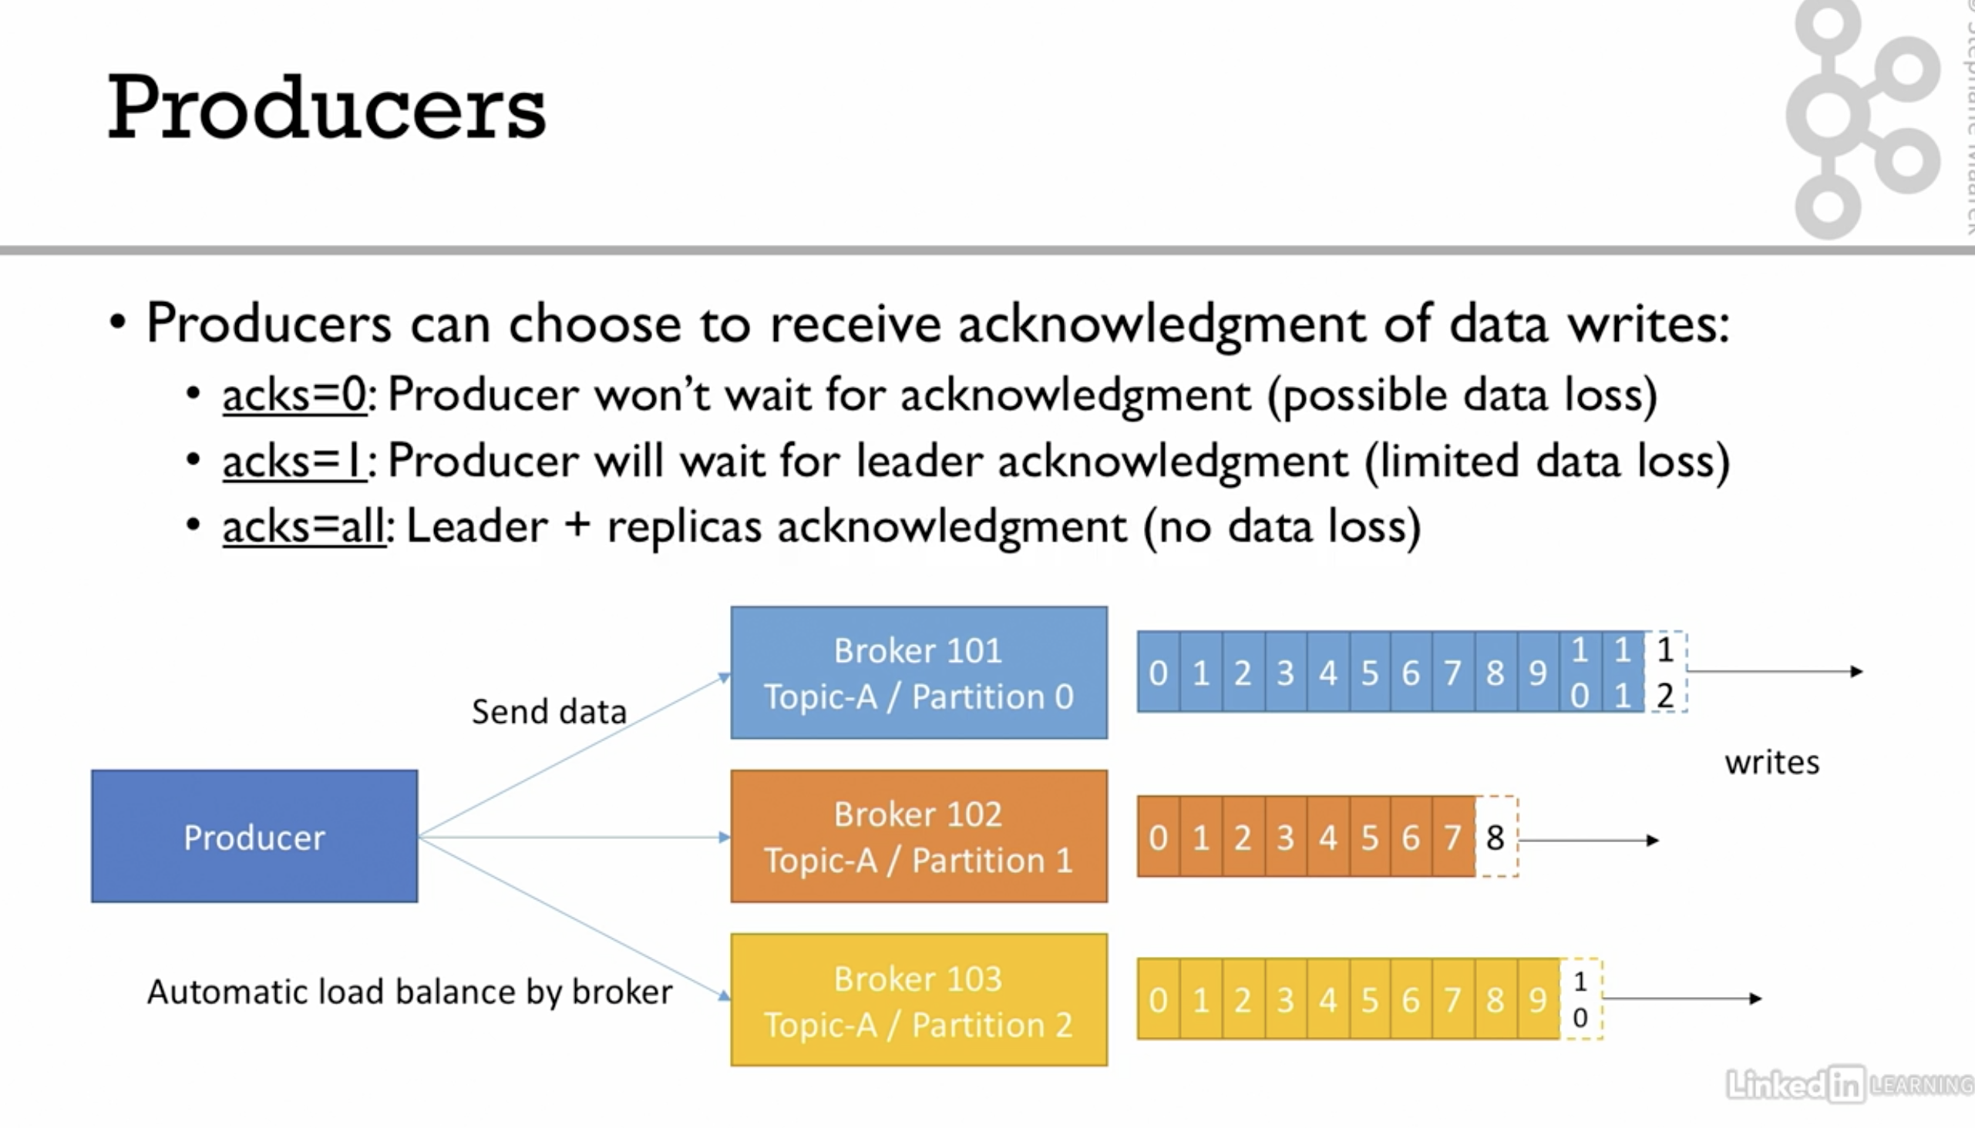

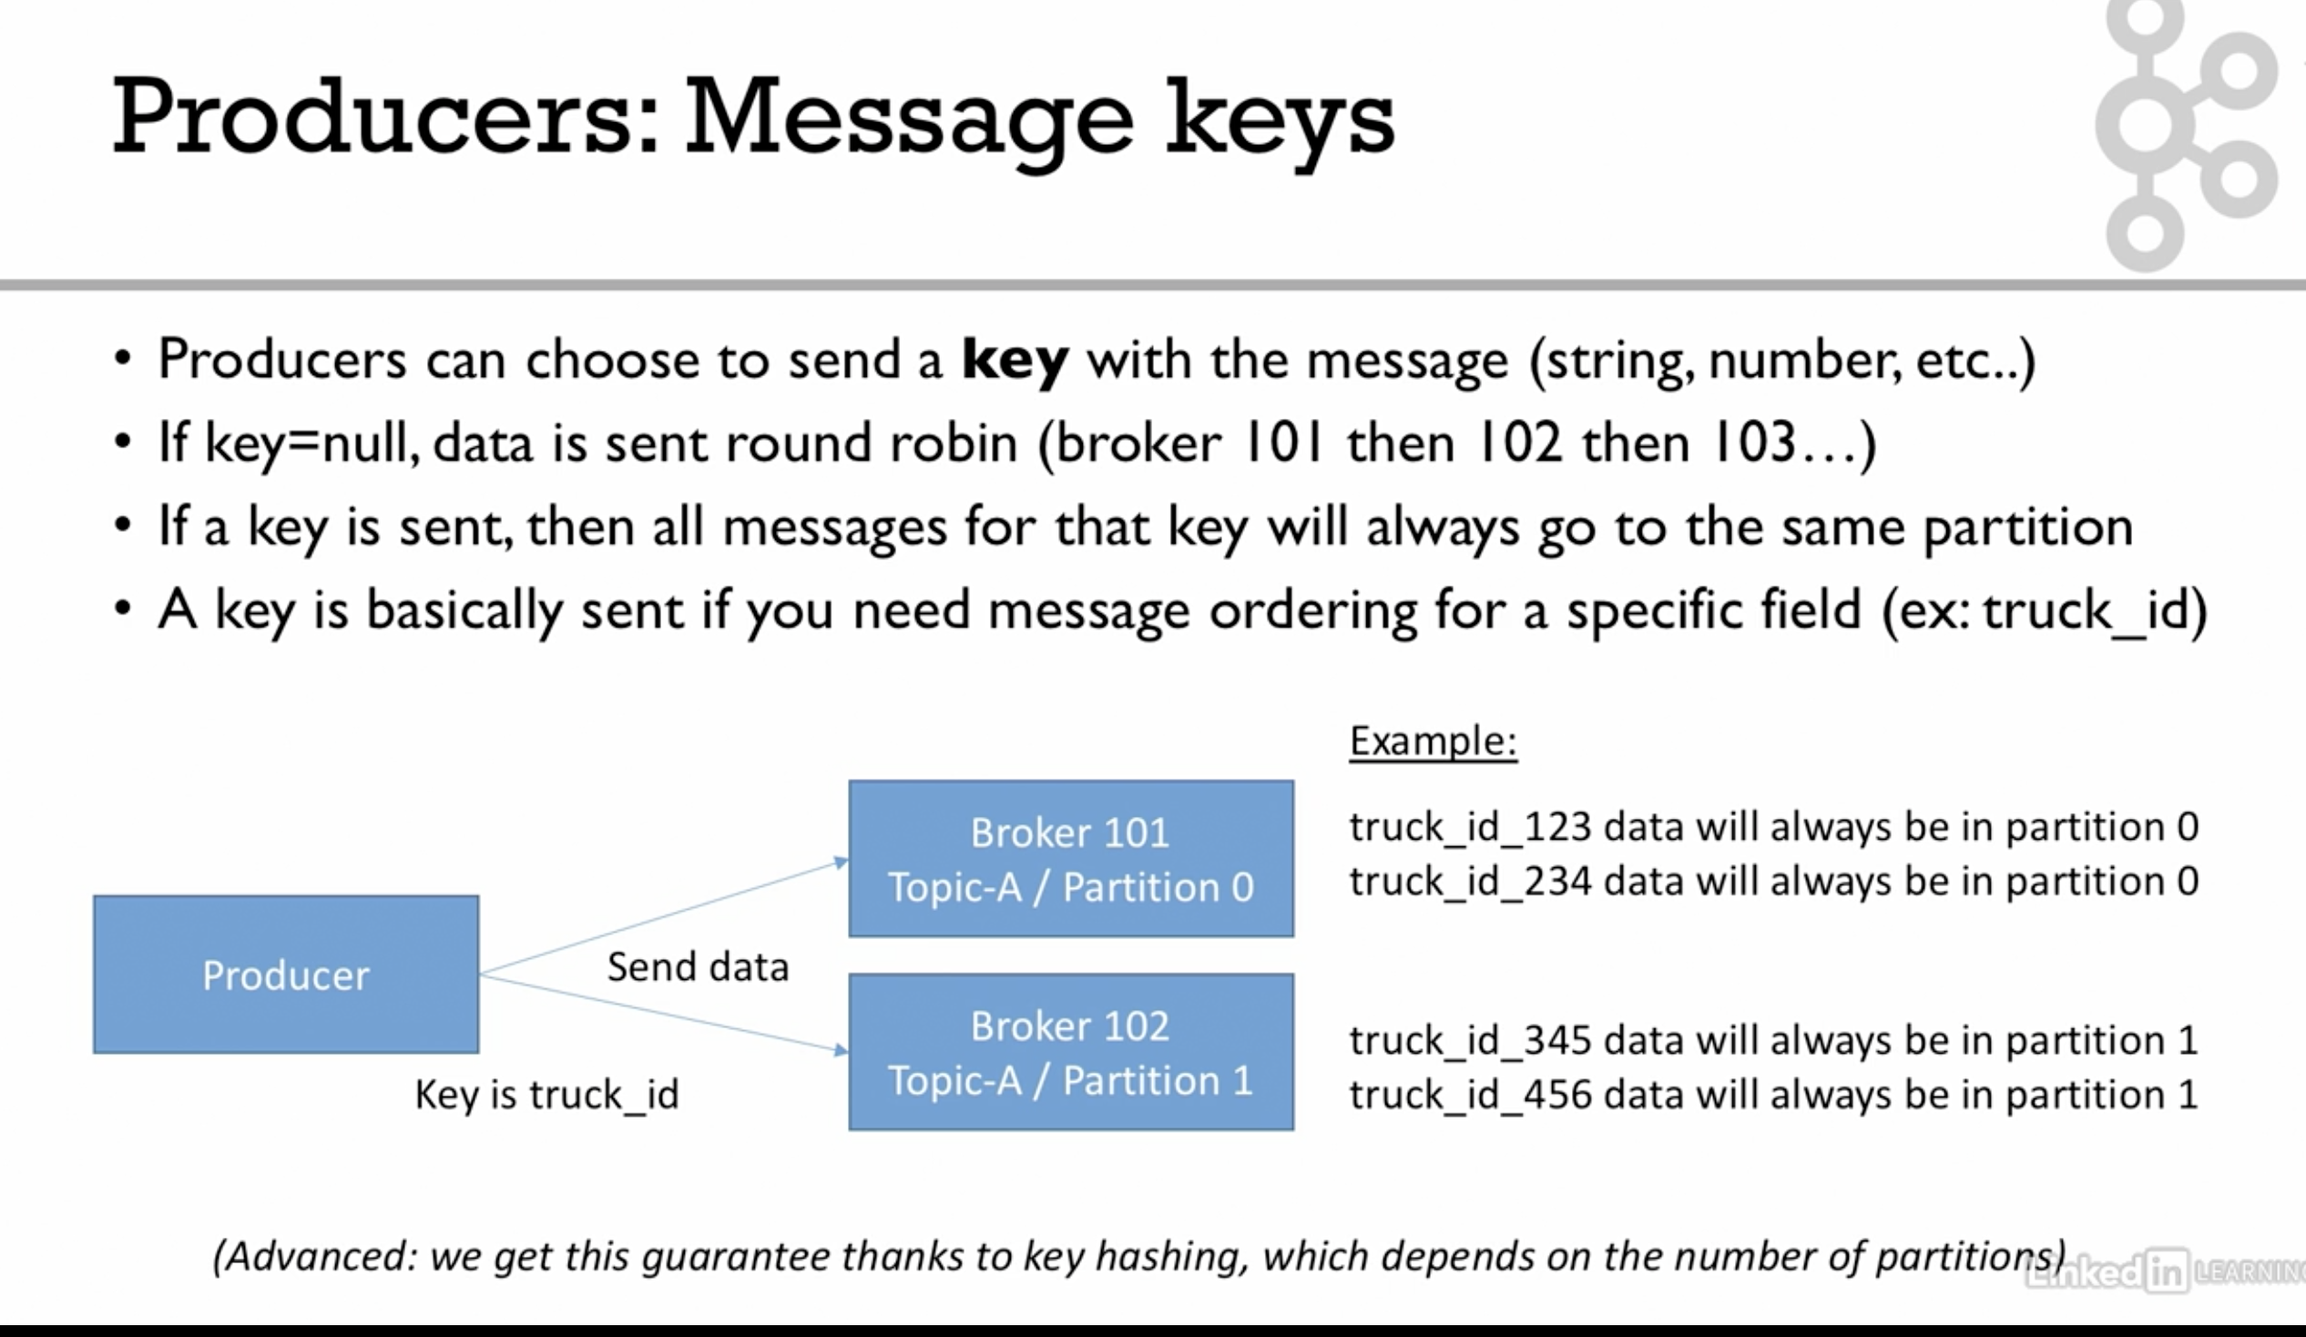

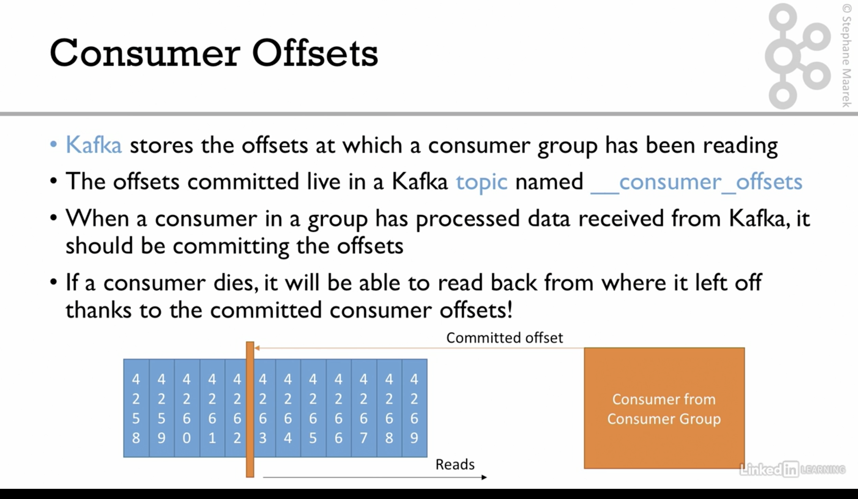

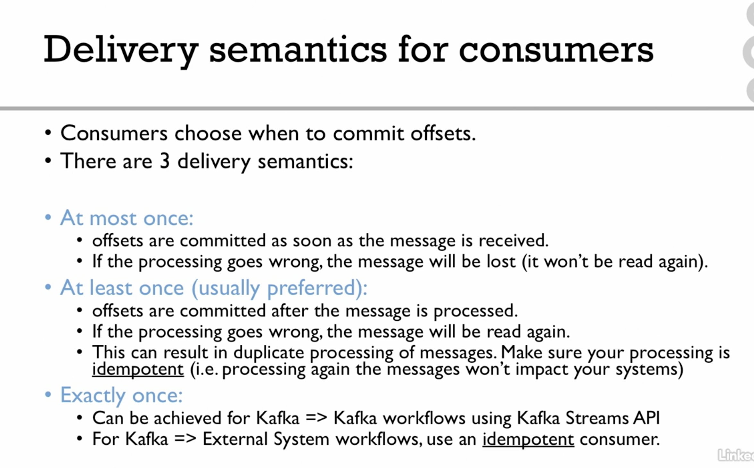

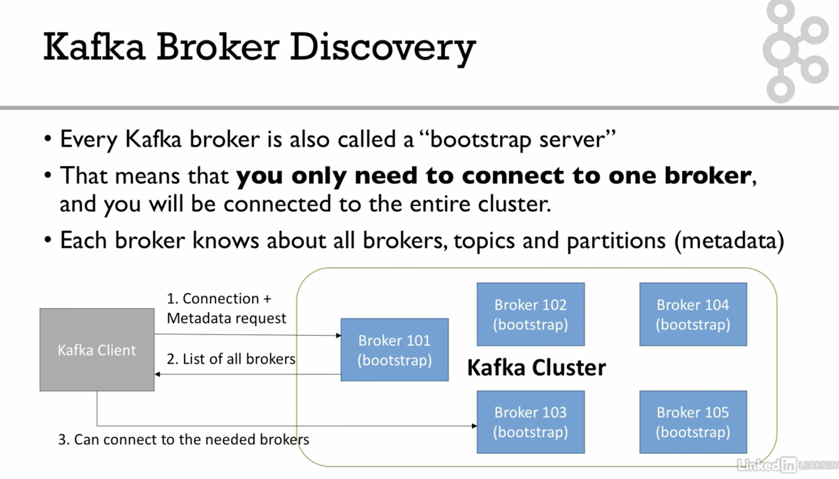

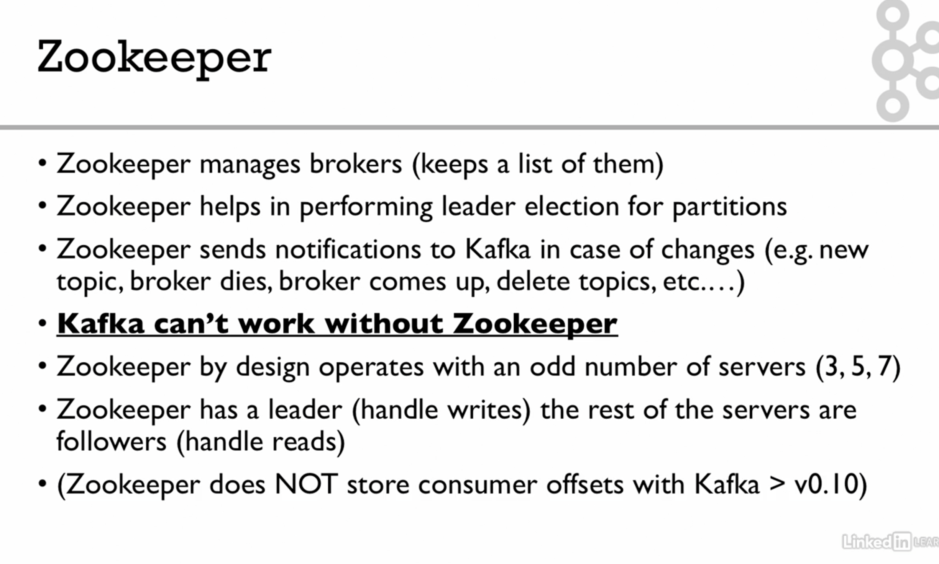

1. Create a topic command

./kafka-topics.sh --bootstrap-server localhost:9092 --topic first_topic --create --partitions 3 --replication-factor 1

1. Describe a topic

./kafka-topics.sh --bootstrap-server localhost:9092 --topic first_topic --describe

Topic: first_topic TopicId: Lms9TRtXQBi3tr9p_KjtJQ PartitionCount: 3

ReplicationFactor: 1 Configs: segment.bytes=1073741824

Topic: first_topic Partition: 0 Leader: 0 Replicas: 0 Isr: 0

Topic: first_topic Partition: 1 Leader: 0 Replicas: 0 Isr: 0

Topic: first_topic Partition: 2 Leader: 0 Replicas: 0 Isr: 0

1. List a topic

./kafka-topics.sh --bootstrap-server localhost:9092 --list

first_topic

4) ./kafka-console-producer.sh --broker-list 127.0.0.1:9092 --topic second_topic

>Animesh

[2021-11-07 15:30:18,122] WARN [Producer clientId=console-producer] Error while fetching metadata with correlation id 3 : {second_topic=LEADER_NOT_AVAILABLE} (org.apache.kafka.clients.NetworkClient)

>Amitabh

>Rashmi

>Pinky

1. Check below producer and consumer, once its configured you can produce the message and consume the message.

